UBND THÀNH PHỐ HỒ CHÍ MINH | CỘNG HÒA XÃ HỘI CHỦ NGHĨA VIỆT NAM
TRƯỜNG CAO ĐẲNG LÝ TỰ TRỌNG | Độc lập - Tự do - Hạnh phúc
THÀNH PHỐ HỒ CHÍ MINH
ĐỀ THI KẾT THÚC HỌC PHẦN LÝ THUYẾT
HỌC KỲ: II NĂM HỌC: 2017 – 2018

Bậc đào tạo: CAO ĐẲNG Học phần: NGHE
Lớp: 17C1-………… Ngày thi: ___ / ___ / 2018
Thời gian thi: 60 phút (không kể thời gian phát đề)

HỌ VÀ TÊN SV |  | Chữ ký Giám thị I | Chữ ký Giám thị II | Số mật mã
LỚP | SỐ KÝ DANH | Chữ ký Giám thị I | Chữ ký Giám thị II | Số mật mã
--------------------------------------------------------------------------------------------------------------------------
Chữ ký Giám khảo I | Chữ ký Giám khảo II | ĐIỂM BÀI THI |  | Số mật mã
 |  | (bằng số) | (bằng chữ)
1. Hướng dẫn làm bài
Đề số 003

Thí sinh không được sử dụng tài liệu khi làm bài.
Sinh viên làm bài ngay trên đề thi.
Bài thi này gồm 40 câu, mỗi câu 0.25 điểm.

2. Nội dung đề thi

Task 1: You will hear about a story.
Number the sentences in the correct order from 1 - 7. Listen three times. (1.5pts)

_____ She kept him awake all night.
_____ She lit many candles and lights.
_____ Her husband was saved.
1 There was a woman who tried to save her
husband’s life by keeping away the lord of death.
_____ When the lord of death came to take her husband,
the lord was blinded by the lights.
_____ She put her jewelry all over the house.
_____ The story explains the significance of the lights
and why Diwali is celebrated.

--------------------------------------------------------------------------------------------------------------------------------------------------
Task 2: Listen. What are these things used for? Circle the correct answers. Listen three times. (1.5pts)
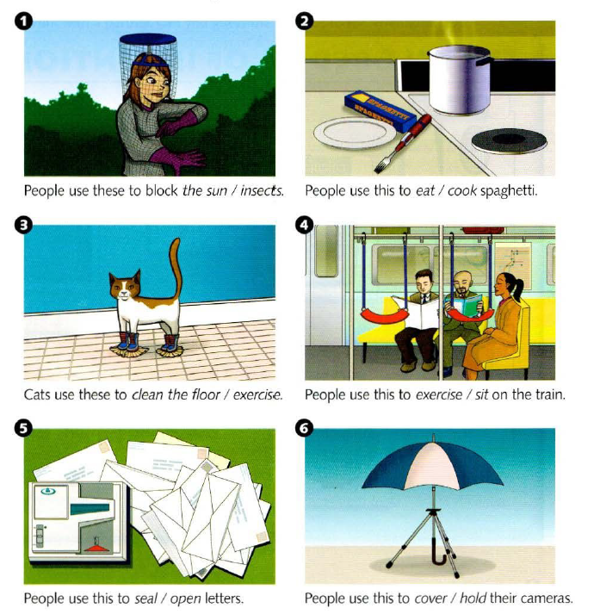

---------------------------------------------------------------------------------------------------------------------------------------
Task 3: Listen and circle the correct answer. Listen three times (1.5pts)

- a. an apology for missing a movie. 4. a. a request to change a meeting time.
b. an invitation to a movie. b. an offer to change a meeting time
c. a cancellation of a movie. c. a promise to change a meeting time.
2. a suggestion about a stereo. 5. a. a suggestion about where to have dinner.
b. a request to borrow a stereo. b. an apology for missing dinner.
c. a complaint about a stereo. c. a complaint about dinner.
3. a. a complaint about a date. 6. a. a complaint about helping Becky move.
b. an invitation to go on a date. b. an invitation to help Becky move.
c. a cancellation of a date. c. a promise to help Becky move.

Task 4: People are describing items they left in a taxi.
Listen and check the correct pictures. Listen three times. (1pt)

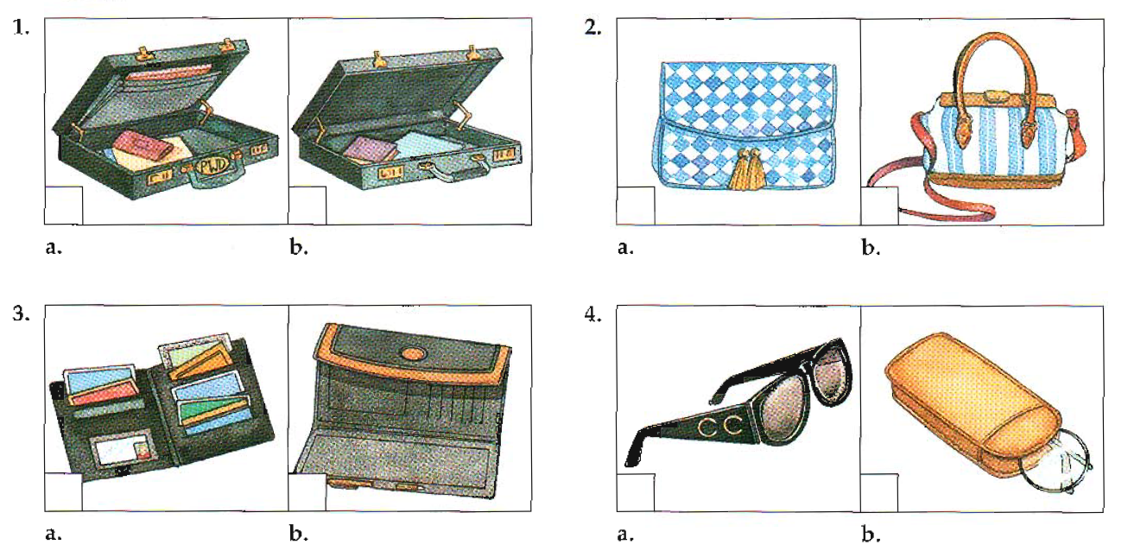

----------------------------------------------------------------------------------------------------------------------------------------
Task 5: Listen again. When are these celebrations?
Write these celebrations in correct months. Listen three times. (1.5pts)
- St.Patrick’s Day 3. Bob Marley Day 5. Kartini Day
- Moon Festival 4. Day of the Dead 6. St. Lucia’s Day
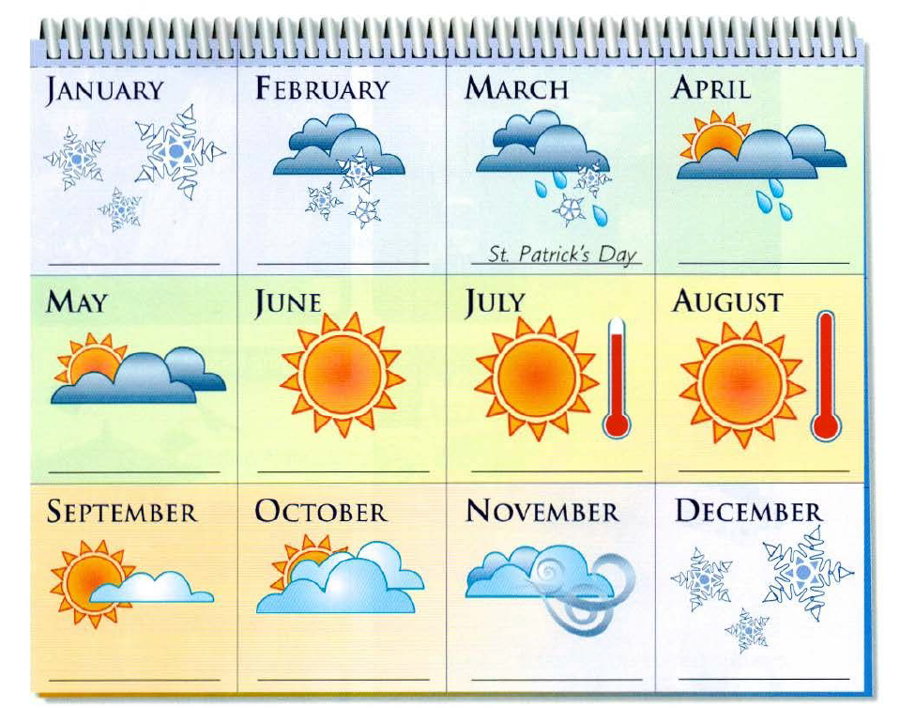

Task 6: Listen and fill in the blanks with the missing words. Listen three times. (3pts)
The capital of Italy is a very old and very famous city. Did you know that many movies are (1) ______________ in Italy? In (2) ______________, over (3) _______________ movies a year are filmed in this old capital. Italian film is (4) ______________ famous for its romances and comedies. This city is a popular city for (5) ______________ films, too.
Famous sites, such as the Coliseum and the Trevi Fountain, are (6) ______________ movie (7) ______________. One of the most popular films was the American hit Roman Holiday, made in 1953.
Every year, people (8) ______________to Italy to see the latest in clothing design. Italian designers are known around the world. In Italy, this city is the (9) ______________ place to see the (10) ______________ fashion designs. Each year, more and more people (11) ______________ the city as fashion (12) _____________.

______Hết_______
GHI CHÚ: CÁN BỘ COI THI KHÔNG ĐƯỢC GIẢI THÍCH GÌ THÊM.

TRƯỞNG KHOA GIẢNG VIÊN RA ĐỀ

Trần Kim Thu Liễu Nguyễn Thị Bảo Trân

